Early Childhood Council
Of La Plata County

Training Registration Form
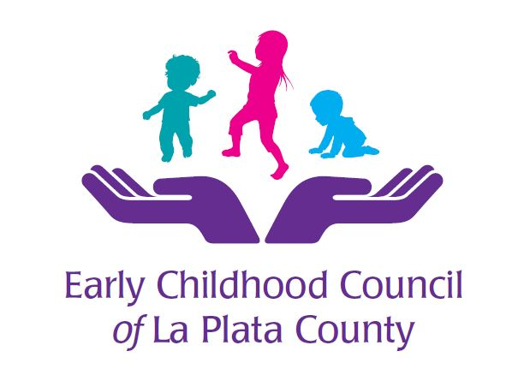
Training | Date / Time | Cost | Location
Pre-Licensing | Saturday July 21 / 28, 2018  9:00 AM – 5:00 / 4:00 PM | $100 /participant | ECCLPC Training Room:  130 Rockpoint Drive Suite C Durango, CO

Registration Deadline: 7/6/2018

Course Description: A state required 15-hour training to become a Licensed Family Child Care provider in the State of Colorado. This course's curriculum is aligned with Colorado’s Core Knowledge and Standards: A Guide for Early Childhood Professionals, and covers the following content areas:
- Overview of Licensing Rules and Regulations
- Child Growth and Development
- Health, Nutrition and Safety
- Developmentally Appropriate Practice
- Guidance
- Family and Community Relationships
- Cultural and Individual Diversity
- Professionalism
- Administration and Supervision

Participant Information (Please print)
Name: |  | County:  Email:
Phone:
Address: |  |  |  | City/ZIP:

☐ Yes, I would like to receive email messages with general information as well as announcements, reminders and updates related to upcoming events from ECCLPC.

Other Information:

Have you already submitted a Licensing Application Packet to the State and/or hold a provisional Family Child Care License?
☐ Yes ☐ No

Please send this completed registration form and check* or money order to:

The Early Childhood Council of La Plata County
P.O. Box 4140
Durango, CO 81302

*Check payable to the Early Childhood Council of La Plata County

Or, register and pay online at www.ecclaplata.org/trainings
Public share/ CBTs/ Registration Forms
Please note that fees are non-refundable unless training is canceled due to inclement weather or trainer illness. Contact Corinne Flieger at 970-247-0760 or corinnef@ecclapata.org with questions.

